## Experiment No. 2

## Aim: Plot and analyze the forward and reverse characteristics of PN junction Si / Ge diode and determine the knee voltage.

**Virtual Lab Link:** http://vlabs.iitkgp.ac.in/be/exp5/forwardbiaseddiode_si.html

**Theory:**

**Function of a P-N junction diode in Forward Bias**

The positive terminal of battery is connected to the P side(anode) and the negative terminal of battery is connected to the N side(cathode) of a diode, the holes in the p-type region and the electrons in the n-type region are pushed toward the junction and start to neutralize the depletion zone, reducing its width. The positive potential applied to the p-type material repels the holes, while the negative potential applied to the n-type material repels the electrons. The change in potential between the p side and the n side decreases or switches sign. With increasing forward-bias voltage, the depletion zone eventually becomes thin enough that the zone's electric field cannot counteract charge carrier motion across the p–n junction, which as a consequence reduces electrical resistance. The electrons that cross the p–n junction into the p-type material (or holes that cross into the n-type material) will diffuse into the nearby neutral region. The amount of minority diffusion in the near-neutral zones determines the amount of current that may flow through the diode.

**Function of a P-N junction diode in Reverse Bias**

The positive terminal of battery is connected to the N side(cathode) and the negative terminal of battery is connected to the P side(anode) of a diode. Therefore, very little current will flow until the diode breaks down.

**Circuit Diagram:**

Forward Bias-Si Diode

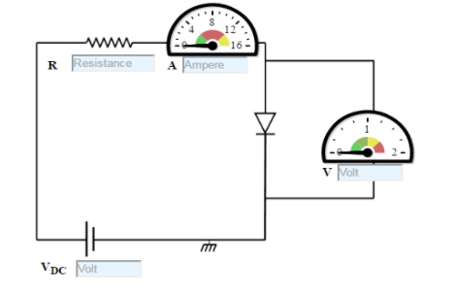

Figure:1

Reverse Bias-Si Diode

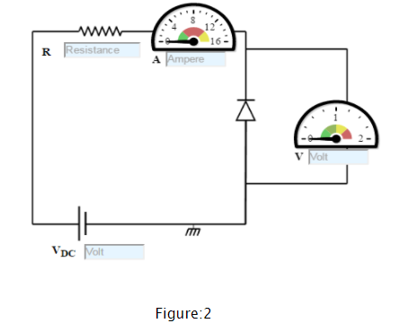

**Procedure:**

Forward Bias-Si Diode

* 1. Set DC voltage to 0.2 V .
  2. Select the diode.
  3. Set the resistor.
  4. Voltmeter is placed parallel to Silicon diode and ammeter series with resistor.
  5. The positive side of battery to the P side(anode) and the negative of battery to the N side(cathode) of the diode.
  6. Now vary the voltage upto 5V and note the Voltmeter and Ammeter reading for particular DC voltage .
  7. Take the readings and note Voltmeter reading across Silicon diode and Ammeter reading.
  8. Plot the V-I graph and observe the change.
  9. Calculate the dynamic resistance of the diode. rd=ΔV/ΔI.
  10. Therefore from the graph we see that the diode starts conducting when the forward bias voltage exceeds around 0.6 volts (for Si diode). This voltage is called cut-in voltage.

Reverse Bias-Si Diode

* 1. Set DC voltage to 0.2 V .
  2. Select the diode.
  3. Set the resistor.
  4. Voltmeter is placed parallel to Silicon diode and ammeter series with resistor.
  5. The positive terminal of battery is connected to the N side(cathode) and the negative terminal of battery is connected to the P side(anode) of a diode.
  6. Now vary the voltage upto 30V and note the Voltmeter and Ammeter reading for DC voltage.
  7. Take the readings and note Voltmeter reading across Silicon diode and Ammeter reading.
  8. Plot the V-I graph and observe the change.

**Observation Table:**

|  |  |  |  |
| --- | --- | --- | --- |
| **Forward Bias** | | | |
| **Sr. No** | **DC voltage (V)** | **Forward voltage (v)** | **Current (mA)** |
| **1.** | 0.2 | 0 | 0 |
| **2.** | 0.7 | 0.572 | 0.502 |
| **3.** | 0.8 | 0.575 | 1.00 |
| **4.** | 1.0 | 0.581 | 2.01 |
| **5.** | 1.2 | 0.586 | 3.01 |
| **6.** | 1.6 | 0.593 | 5.02 |
| **7.** | 1.9 | 0.597 | 6.52 |
| **8.** | 2.3 | 0.602 | 8.53 |
| **9.** | 2.6 | 0.606 | 10.0 |
| **10.** | 2.8 | 0.608 | 11.0 |

|  |  |  |  |
| --- | --- | --- | --- |
| **Reverse Bias** | | | |
| **Sr. No** | **DC voltage (V)** | **Reverse voltage (v)** | **Reverse Current (µA)** |
| **1.** | 0.2 | 0.161 | 0.100 |
| **2.** | 2.25 | 1.98 | 0.100 |
| **3.** | 4.15 | 3.73 | 0.100 |
| **4.** | 6.5 | 5.93 | 0.100 |
| **5.** | 9.1 | 8.40 | 0.100 |
| **6.** | 13.5 | 12.6 | 0.100 |
| **7.** | 17 | 16.0 | 0.100 |
| **8.** | 20.1 | 19.0 | 14.977 |
| **9.** | 21.55 | 20.5 | 16.058 |
| **10.** | 23.9 | 22.8 | 17.809 |

**Calculate Value of static resistance, $R_{d }= \frac{V}{I}$:** 0.317

**Value of dynamic resistance, $r_{d }= \frac{∆V}{∆I}$: 1.33**

**Graph:**

**Forward Bias-**

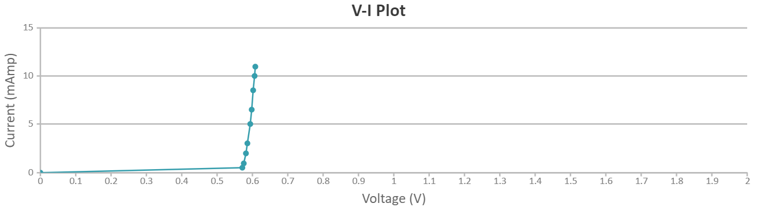

**Reverse Bias-**

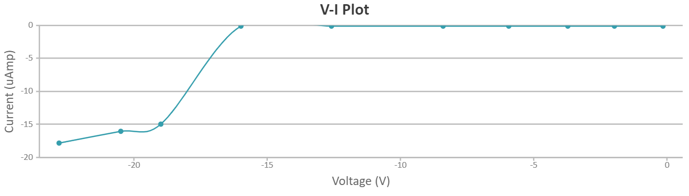

**Conclusion:**

1. **The change in current when voltage across diode is less than knee voltage is** minimum **during forward biasing.**
2. **The current** increases **when voltage across diode exceeds knee voltage during forward biasing.**
3. **The value of peak inverse voltage across diode in reverse biasing is** 20.1V